**FACTORIAL NUMBER**  
  
**AIM:**To write an assembly language program to implement factorial number using 8085 processor.  
**ALGORITHM:**  
1)   Start the program by loading a register pair with address of 1st number.  
2)   Copy the data to another register pair.  
3)    Load the second number to first register pair.  
4)    Subtract the two register pair contents.  
5)    Check for borrow.  
6)    Store the value of difference and borrow in memory locations.  
7)    End.   
**PROGRAM:**

LXI H, 8000H

MOV B,M

MVI D, 01H

FACT: CALL MUL

DCR B

JNZ FACT

INX H

MOV M,D

HLT

MUL: MOV E,B

XRA A

ML: ADD D

DCR E

JNZ ML

MOV D,A

RET

HLT

INPUT:

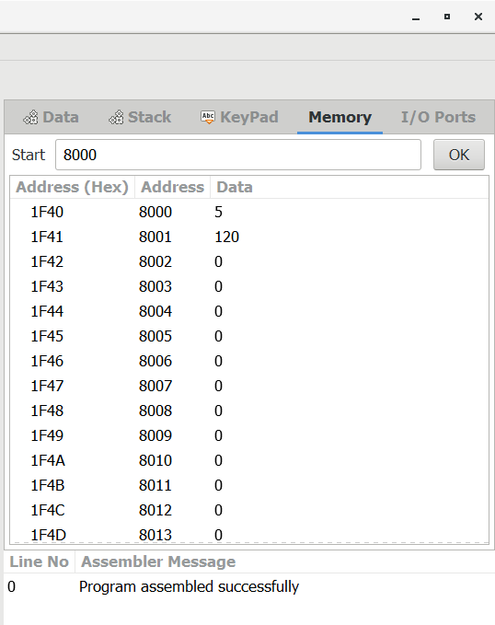

OUTPUT:

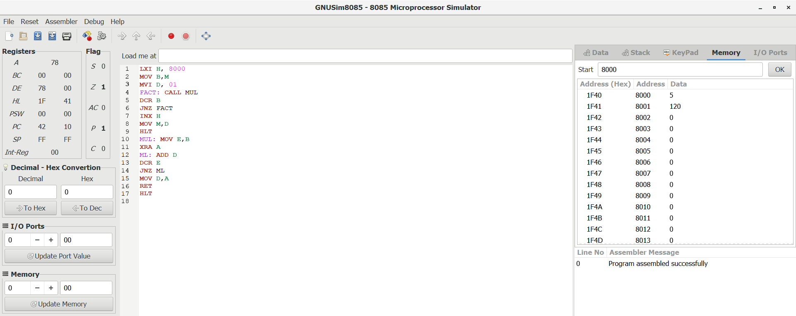

RESULT: Thus the program was executed successfully using 8085 processor.